Architecture:

Project Design Phase-II Technology Stack (Architecture & Stack)

|  |  |
| --- | --- |
| Date | 27 June 2025 |
| Team ID | LTVIP2025TMID59395 |
| Project Name | BookNest: Where Stories Nestle |
| Maximum Marks | 4 Marks |

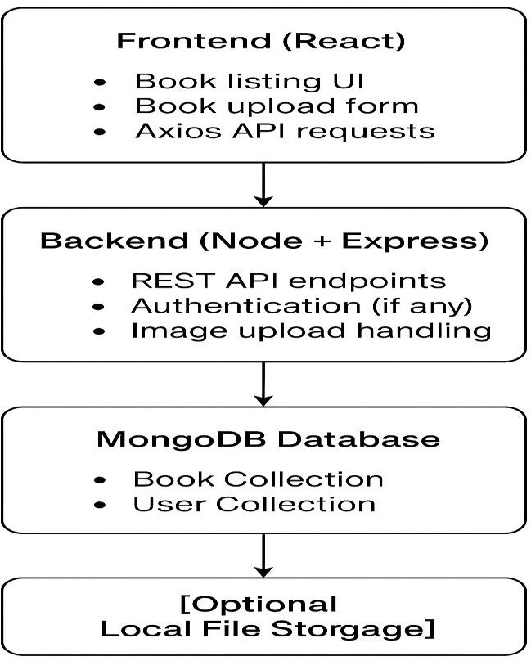

Architecture Overview:

The BookNest project follows a typical 3-tier architecture consisting of:

1. Frontend Layer (Client-Side): Built with React.js, it allows users to browse, add, and view books.
2. Backend Layer (Server-Side): Node.js with Express handles API requests, business logic, and routes.
3. Database Layer: MongoDB stores all book records and user-related data.
4. Local File Storage: Used for storing book images and other uploads.

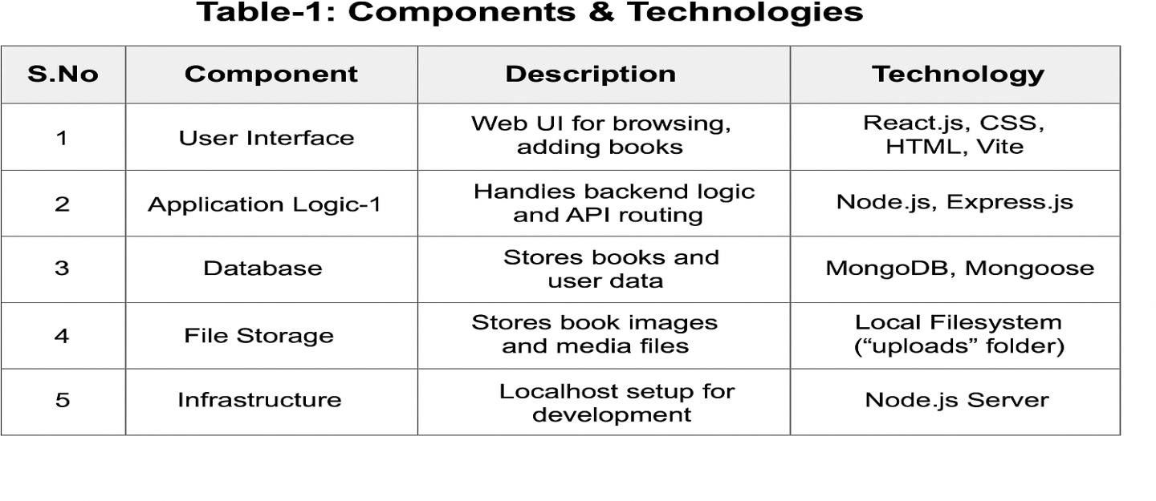

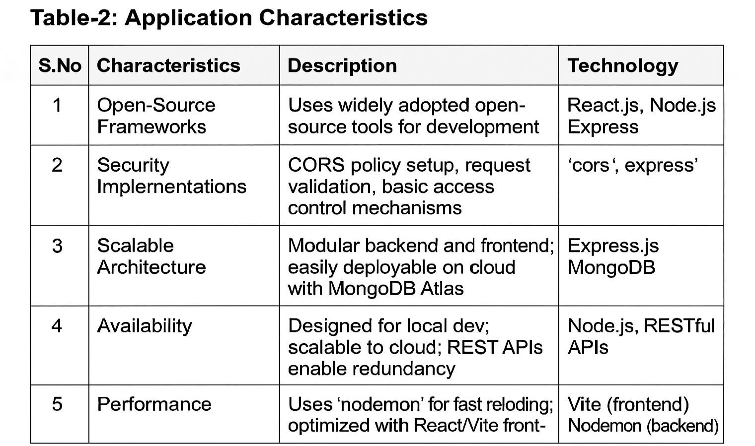

 References (with Titles & Links)

* 1. **C4 Model for Visualising Software Architecture ** [**https://c4model.com/**](https://c4model.com/)
  2. **AI-powered backend system for order processing during pandemics**

 <https://developer.ibm.com/patterns/online-order-processing-system-during-pandemic/>

* 1. **IBM Cloud Architecture Center**

 <https://www.ibm.com/cloud/architecture>

* 1. **AWS Architecture Center**

 <https://aws.amazon.com/architecture>

* 1. **How to draw useful technical architecture diagrams – Medium Article**

 https://medium.com/the-internal-startup/how-to-draw-useful-technical-architecture-diagrams-2d20c9fda90d